Q.1. Define Covariance and explain how it differs from Correlation in terms of scale and interpretation.
Ans,
Covariance measures how two variables change together, while correlation standardizes this relationship to make it scale-free and easier to interpret. The key difference is that covariance depends on the units of measurement, whereas correlation always lies between -1 and +1, making it universally comparable.
Covariance: Definition
- Meaning: Covariance indicates the direction of the linear relationship between two variables.
- Formula:
\mathrm{Cov}(X,Y)=\frac{\sum (X_i-\bar {X})(Y_i-\bar {Y})}{n-1}
- Interpretation:
  - Positive covariance → variables increase together.
  - Negative covariance → one increases while the other decreases.
  - Near zero → weak or no linear relationship.
- Scale-dependent: The magnitude of covariance depends on the units of the variables (e.g., cm vs. m, rupees vs. dollars).
Correlation: Definition
- Meaning: Correlation measures both the direction and strength of the linear relationship.
- Formula:
r=\frac{\mathrm{Cov}(X,Y)}{\sigma _X\cdot \sigma _Y}
- Interpretation:
  - Ranges between -1 and +1.
  - +1 → perfect positive linear relationship.
  - -1 → perfect negative linear relationship.
  - 0 → no linear relationship.
- Scale-free: Because it divides covariance by the product of standard deviations, correlation is independent of measurement units.
Key Differences Between Covariance and Correlation
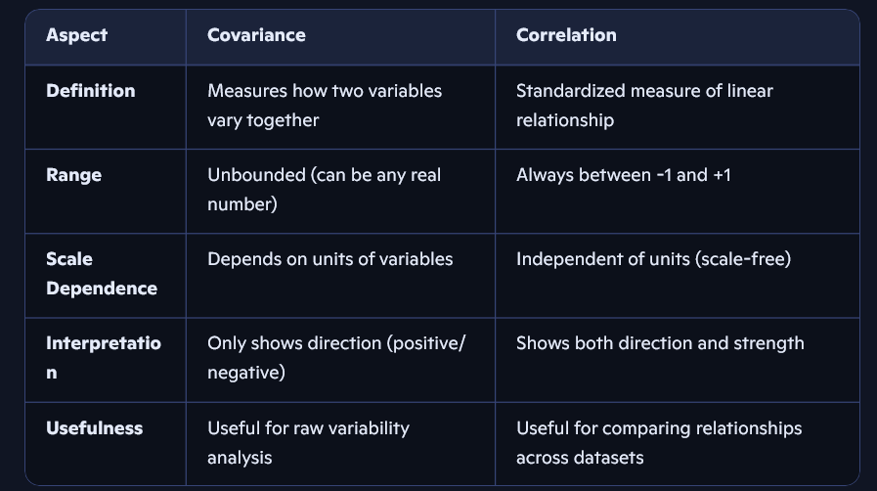
Practical Example
- Suppose we measure height (cm) and weight (kg):
- Covariance might be 1200, but this number is hard to interpret because it depends on the units.
- Correlation might be 0.85, which clearly indicates a strong positive relationship regardless of units.

Q2. What does a positive, negative, and zero covariance indicate about the relationship between two variables.
Ans.
Here’s a clear breakdown of what positive, negative, and zero covariance indicate about the relationship between two variables:

➕ Positive Covariance
- Meaning: When one variable increases, the other tends to increase as well.
- Example: Height and weight — generally, taller people tend to weigh more.
- Interpretation: Both variables move in the same direction.

➖ Negative Covariance
- Meaning: When one variable increases, the other tends to decrease.
- Example: Speed of a car and travel time — as speed increases, travel time decreases.
- Interpretation: Variables move in opposite directions.

0️⃣ Zero Covariance
- Meaning: No consistent linear relationship between the two variables.
- Example: Shoe size and exam scores — changes in one don’t affect the other.
- Interpretation: Variables are independent in terms of linear movement (though they may still have a nonlinear relationship).

Summary Table


Q3. Discuss the limitations of covariance as a measure of relationship between two variables. Why is correlation preferred in many cases
Ans.
Limitations of Covariance
- Scale Dependence
  - Covariance values depend on the units of measurement.
  - Example: If height is measured in cm vs. meters, covariance changes drastically, making comparisons meaningless.
- Unbounded Values
  - Covariance can take any real number (positive, negative, or large magnitude).
  - This makes it difficult to interpret the strength of the relationship.
- Interpretation Difficulty
  - A positive or negative sign shows direction, but the magnitude doesn’t clearly indicate how strong the relationship is.
  - For instance, a covariance of 1200 doesn’t tell us if the relationship is “strong” or “weak” without context.
- Not Comparable Across Datasets
- Since covariance depends on scale, you cannot compare covariance values between different datasets or variables measured in different units.
✅ Why Correlation is Preferred
- Standardized Measure
  - Correlation divides covariance by the product of standard deviations, removing unit dependence.
  - This makes correlation values consistent and comparable.
- Bounded Range (-1 to +1)
  - Easy to interpret:
  - +1 → perfect positive linear relationship
  - -1 → perfect negative linear relationship
  - 0 → no linear relationship
- Strength + Direction
  - Correlation shows both the direction (positive/negative) and the strength (magnitude close to 1 or 0) of the relationship.
- Widely Applicable
- Because correlation is scale-free, it is useful in comparing relationships across different datasets, variables, or contexts.
Summary Table.
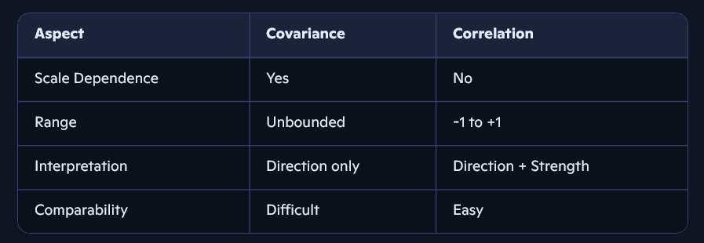

Q4. Explain the difference between Pearson’s correlation coefficient and Spearman’s rank correlation coefficient. When would you prefer to use Spearman’s correlation?
Ans,
Here’s a clear explanation of the difference between Pearson’s correlation coefficient and Spearman’s rank correlation coefficient, along with when Spearman’s is preferred:
📊 Pearson’s Correlation Coefficient
- Definition: Measures the linear relationship between two continuous variables.
- Formula:
r=\frac{\mathrm{Cov}(X,Y)}{\sigma _X\cdot \sigma _Y}
- Assumptions:
  - Variables are normally distributed.
  - Relationship is linear.
  - Sensitive to outliers.
- Interpretation:
- Values range from -1 to +1.
- Closer to ±1 → stronger linear relationship.
- 0 → no linear relationship.
📈 Spearman’s Rank Correlation Coefficient
- Definition: A non-parametric measure of correlation based on the ranks of data rather than raw values.
- Formula (simplified for ranked data):
\rho =1-\frac{6\sum d_i^2}{n(n^2-1)}
- where d_i = difference between ranks of each pair, and n = number of observations.
- Assumptions:
  - No requirement of normal distribution.
  - Captures monotonic relationships (increasing or decreasing, not necessarily linear).
  - Less sensitive to outliers.
- Interpretation:
- Also ranges from -1 to +1.
- Works well with ordinal data or skewed distributions.
Key Differences
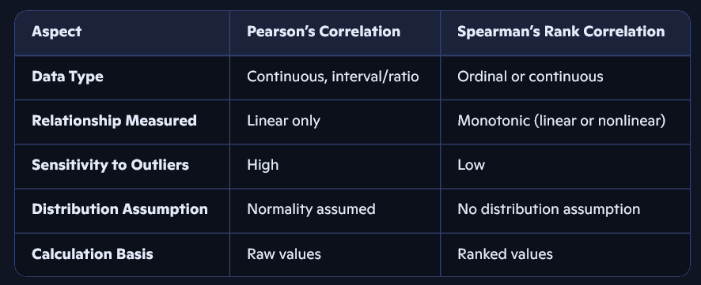

Q5. If the correlation coefficient between two variables X and Y is 0.85, interpret this value in context. Can you infer causation from this value? Why or why not?
Ans,
Here’s a clear interpretation of the correlation coefficient value 0.85 and why it does not imply causation:
Interpretation of r = 0.85

- Strength: A correlation of 0.85 indicates a strong positive linear relationship between variables X and Y.
- Direction: As X increases, Y tends to increase as well.
- Example: If X = hours studied and Y = exam score, a correlation of 0.85 suggests that more study hours are strongly associated with higher scores.
Can We Infer Causation?
- No, correlation ≠ causation.
- Reasons:
- Third Variable Problem: A hidden variable (Z) may influence both X and Y.
  - Example: Ice cream sales (X) and drowning incidents (Y) may correlate, but the hidden factor is temperature (Z).
- Directionality Problem: Even if X and Y are related, correlation doesn’t tell us whether X causes Y or Y causes X.

- Coincidence: Sometimes correlations occur by chance, especially in large datasets.

.
Q6. Using the dataset below, calculate the covariance between X and Y.

Ans. Step-by-Step Covariance Calculation:
- Find the means of X and Y:
  - Mean of X: (1+3+6+8)/4=18/4=4.5
  - Mean of Y: (2+5+8+10)/4=25/4=6.25.

- Apply the covariance formula:
\mathrm{Cov}(X,Y)=\frac{1}{n}\sum _{i=1}^n(X_i-\bar {X})(Y_i-\bar {Y})

- Compute each term:
  - For i=1: (1-4.5)(2-6.25)=(-3.5)(-4.25)=14.875
  - For i=2: (3-4.5)(5-6.25)=(-1.5)(-1.25)=1.875
  - For i=3: (6-4.5)(8-6.25)=(1.5)(1.75)=2.625
  - For i=4: (8-4.5)(10-6.25)=(3.5)(3.75)=13.125

- Sum of products:
14.875+1.875+2.625+13.125=32.5

- Divide by n (4):
\mathrm{Cov}(X,Y)=\frac{32.5}{4}=8.125
✅ Final Answer:
Covariance between X and Y = 8.125

Q7. Compute the Pearson correlation coefficient between variables A and B.

Ans.
Step-by-Step Pearson Correlation Calculation:
- Find the means of A and B:
  - Mean of A: (10+20+30+40+50)/5=150/5=30
  - Mean of B: (14+18+24+28+30)/5=114/5=22.8
- Apply the Pearson formula:
r=\frac{\sum (A_i-\bar {A})(B_i-\bar {B})}{\sqrt{\sum (A_i-\bar {A})^2\cdot \sum (B_i-\bar {B})^2}}
Compute each term:

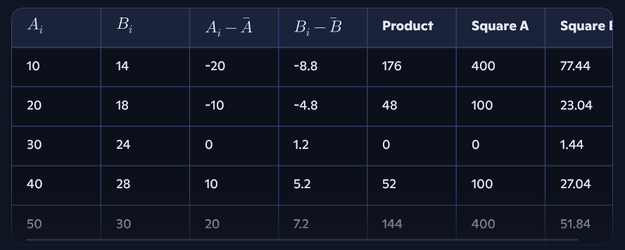
Sum of products: 176+48+0+52+144=420
- Sum of squares A: 400+100+0+100+400=1000
- Sum of squares B: 77.44+23.04+1.44+27.04+51.84=180.8
- Plug into formula:
r=\frac{420}{\sqrt{1000\cdot 180.8}}=\frac{420}{\sqrt{180800}}\approx \frac{420}{424.99}\approx 0.988

Q8. The following table shows heights (in cm) and weights (in kg) of 5 students. Find the correlation coefficient between Height and Weight.
Ans,
Step-by-Step Pearson Correlation Calculation:
- Find the means:
  - Mean of Height: (150+160+165+170+180)/5=825/5=165
  - Mean of Weight: (50+55+58+62+70)/5=295/5=59
- Apply the Pearson formula:
r=\frac{\sum (H_i-\bar {H})(W_i-\bar {W})}{\sqrt{\sum (H_i-\bar {H})^2\cdot \sum (W_i-\bar {W})^2}}
- Compute each term:
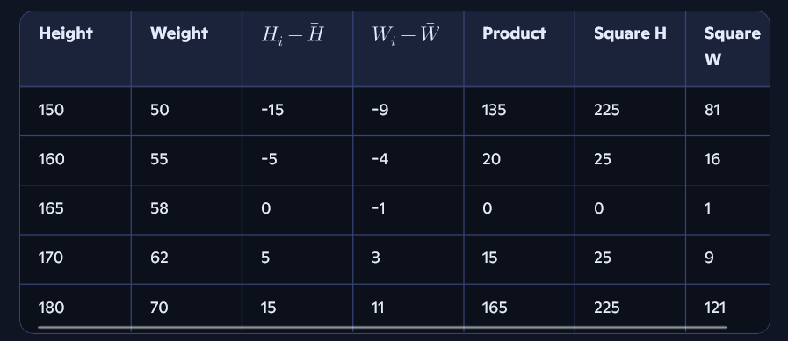
Sum of products: 135+20+0+15+165=335
- Sum of squares H: 225+25+0+25+225=500
- Sum of squares W: 81+16+1+9+121=228
- Plug into formula:
r=\frac{335}{\sqrt{500\cdot 228}}=\frac{335}{\sqrt{114000}}\approx \frac{335}{337.64}\approx 0.993

Q9. Given the dataset below, determine whether there is a positive or negative correlation between X and Y. (No need for exact calculation, just reasoning).
Ans,
Reasoning:
- As X increases from 1 to 5, Y decreases from 15 to 3.
- This shows an inverse relationship — when one variable goes up, the other goes down.
✅ Final Answer:
There is a negative correlation between X and Y.

Q10. Two investment portfolios have the following returns (%) over 5 years. Compute the covariance and correlation coefficient, and interpret whether the portfolios move together.
Ans,
Step 1: Calculate Means
- Mean of A: (8+10+12+9+11)/5=50/5=10
- Mean of B: (6+8+11+8+10)/5=43/5=8.6
Step 2: Covariance Calculation
Use the formula:
\mathrm{Cov}(A,B)=\frac{1}{n}\sum (A_i-\bar {A})(B_i-\bar {B})
 |  | A_i-\bar {A} | B_i-\bar {B}
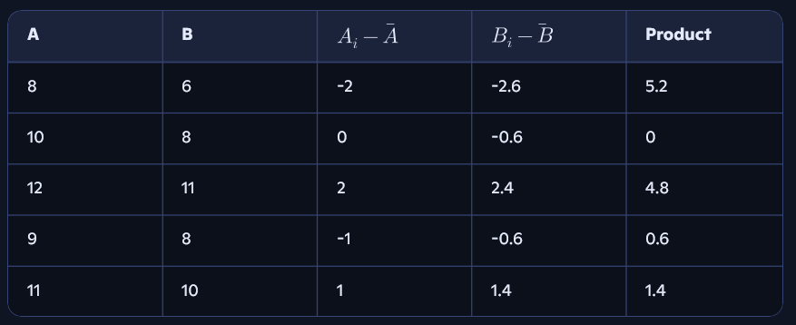

Sum of products: 5.2+0+4.8+0.6+1.4=12
- Covariance: 12/5=2.4
Step 3: Correlation Coefficient
Use the formula:
r=\frac{\mathrm{Cov}(A,B)}{\sigma _A\cdot \sigma _B}
First, calculate standard deviations:
- Variance of A:
\frac{(-2)^2+0^2+2^2+(-1)^2+1^2}{5}=\frac{4+0+4+1+1}{5}=\frac{10}{5}=2\Rightarrow \sigma _A=\sqrt{2}\approx 1.414
- Variance of B:
\frac{(-2.6)^2+(-0.6)^2+2.4^2+(-0.6)^2+1.4^2}{5}=\frac{6.76+0.36+5.76+0.36+1.96}{5}=\frac{15.2}{5}=3.04\Rightarrow \sigma _B=\sqrt{3.04}\approx 1.744
- Correlation:
r=\frac{2.4}{1.414\cdot 1.744}\approx \frac{2.4}{2.466}\approx 0.974
✅ Final Answer:
- Covariance = 2.4
- Correlation coefficient ≈ 0.974
Interpretation:
There is a strong positive correlation between Portfolio A and Portfolio B — they tend to move together in the same direction.
Want help summarizing this for your assignment or converting it into a slide?

